Predicting Flight Delay Severity for Flights Departing from Harrisburg International Airport (MDT) Using Machine Learning

Gracie Nguyen, Nam Nguyen, Leah Ho

1. Problem Description and Goals
Flight delays are one of the most significant operational challenges in the airline industry. Delays affect passenger satisfaction, airport congestion, airline scheduling, aircraft utilization, crew management, and overall transportation efficiency. Predicting delays accurately can help airlines and airports improve scheduling decisions, resource allocation, and operational planning.
This project focuses specifically on flights departing from Harrisburg International Airport (MDT). Using historical flight performance data from the Bureau of Transportation Statistics On-Time Performance dataset, this project predicts flight delay severity as a multiclass classification problem.
Flights were classified into four categories:
- On-time
- Minor Delay
- Moderate Delay
- Severe Delay
The main goal was to evaluate how well different machine learning algorithms could predict delay severity for flights departing from MDT.
The project specifically aimed to:
- Build multiclass machine learning models for flight delay severity prediction
- Compare Logistic Regression, Random Forest, and XGBoost
- Analyze the operational variables that contribute most strongly to delays
- Evaluate model performance under severe class imbalance
- Examine precision-recall tradeoffs and probability behavior
- Interpret feature importance across models
Unlike binary delay prediction, multiclass delay severity prediction presents a more realistic and difficult operational problem because models must distinguish among multiple levels of disruption rather than simply identifying whether a delay occurred.

2. Team Member Roles
Gracie Nguyen led data preparation, preprocessing, exploratory data analysis, feature engineering, visualization development, model interpretation, and final report writing. Responsibilities included preparing the multiclass delay labels, analyzing class imbalance, generating ROC and precision-recall visualizations, evaluating confusion matrices, and interpreting feature importance across models.
Nam Nguyen focused primarily on machine learning implementation, model training, hyperparameter tuning, and algorithm comparison. This included implementing Logistic Regression, Random Forest, and XGBoost models and assisting with evaluation metric analysis and optimization procedures.
Leah Ho supported dataset preparation and filtering, including selecting flights departing from MDT, exploratory analysis, feature selection, documentation support, and assistance with visualizations and presentation preparation.
All team members collaborated on project planning, interpretation of results, and preparation of the final presentation.

3. State-of-the-Art / Related Work
Machine learning has increasingly been used in transportation analytics because airline operational systems involve large-scale nonlinear interactions between scheduling, airport congestion, aircraft utilization, carrier operations, and external disruptions. Traditional statistical methods often struggle to capture these complex relationships.
Previous research commonly uses:
- Logistic Regression
- Decision Trees
- Random Forest
- Gradient Boosting
- XGBoost
- Neural Networks
for airline delay prediction tasks.
Many previous studies focus primarily on binary classification problems that determine whether a flight is delayed or not delayed. However, operational systems benefit more from understanding delay severity because airlines and airports must allocate resources differently depending on whether delays are minor or severe.
Previous research has identified several important operational predictors of delays, including:
- Departure time
- Carrier performance
- Flight distance
- Airport congestion
- Seasonal timing patterns
- Previous aircraft delays
Our project extends this work by focusing specifically on multiclass delay severity prediction for flights departing from Harrisburg International Airport (MDT), allowing for more detailed operational analysis.

4. Approach

4.1 Dataset
The dataset used in this project came from the Bureau of Transportation Statistics On-Time Performance dataset, which contains operational records for U.S. domestic airline flights.
The dataset was filtered to include only flights departing from Harrisburg International Airport (MDT). Key variables included:
- YEAR
- MONTH
- DAY_OF_MONTH
- DAY_OF_WEEK
- CRS_DEP_TIME
- OP_UNIQUE_CARRIER
- DEST
- DISTANCE
- CRS_ELAPSED_TIME
- TAIL_NUM
- ARR_DELAY_NEW
The final target variable was not directly treated as a binary delay indicator. Instead, arrival delay minutes were transformed into a four-class delay severity outcome using K-Means clustering on delayed flights, while on-time flights were assigned to their own class.
The target variable classified flights into four delay severity categories:
- On-time
- Minor
- Moderate
- Severe
This substantially increased the complexity of the prediction problem because the models needed to distinguish among multiple operational outcomes.

4.2 Dataset Imbalance
The dataset was highly imbalanced. After preprocessing, outlier capping, and K-Means clustering, the final delay severity distribution showed a strong dominance of On-time flights and relatively few Severe delay observations.
Final class distributions in the full dataset were:
- On-time: 20,367 observations
- Minor Delay: 6,593 observations
- Moderate Delay: 1,657 observations
- Severe Delay: 664 observations
The Severe delay category represented only a small portion of the dataset, creating substantial challenges for multiclass classification.
Before clustering, extreme delay values above 243 minutes were capped at the 99th percentile to reduce the influence of rare outlier delays. K-Means clustering was then applied to delayed flights to identify natural groupings of delay severity. The resulting cluster centers were approximately:
- Minor Delay: 15.54 minutes
- Moderate Delay: 85.89 minutes
- Severe Delay: 213.96 minutes
This clustering approach allowed the project to create data-driven delay severity categories rather than relying on manually selected thresholds.

4.3 Feature Engineering and Preprocessing
The preprocessing stage began by filtering the dataset to include only flights departing from Harrisburg International Airport (MDT). Cancelled flights were removed because they do not represent completed flight delay outcomes. Observations with missing arrival delay information were also removed so that each record had a valid delay outcome for modeling. After filtering, the dataset was reduced to the variables most relevant to the prediction task, including date and time variables, carrier, destination airport, flight distance, scheduled elapsed time, aircraft tail number, and arrival delay information.
Several variables were converted into appropriate numeric formats before modeling. DISTANCE,
CRS_DEP_TIME, and CRS_ELAPSED_TIME were converted to numeric values, while delay variables were converted to integer format. Any remaining rows with missing values after these conversions were dropped. This ensured that all machine learning models received complete and consistently formatted input data.
A major engineered time feature was DEP_HOUR, which was created from the scheduled departure time variable CRS_DEP_TIME. Since CRS_DEP_TIME is stored in military time format, the hour of departure was extracted by dividing by 100 and keeping the integer hour. This transformed raw departure time into a more interpretable feature that captures time-of-day patterns, such as whether delays are more common in the morning, afternoon, or evening.
Another important engineered feature was PREV_FLIGHT_DELAYED. To create this feature, the flight date variable FL_DATE was converted into a datetime format, and the dataset was sorted by aircraft tail number, flight date, and scheduled departure time. Then, for each aircraft on each day, the previous row’s delay indicator was shifted forward to identify whether the aircraft’s previous flight had been delayed. The first flight of the day for each aircraft had no previous flight, so missing values were filled with 0. This feature was important because it allowed the model to capture delay propagation, where a late earlier flight may affect later flights using the same aircraft.
The final target variable was created using ARR_DELAY_NEW, which records arrival delay in minutes. Before forming delay severity groups, extreme delay values were capped at the 99th percentile to reduce the influence of rare outliers. Then, only flights with positive arrival delays were clustered using K-Means with three clusters. These three clusters represented natural groupings among delayed flights and were ordered by severity based on the cluster centers. On-time flights were assigned to class 0, while the three K-Means delay groups were assigned to classes 1, 2, and 3. As a result, the final multiclass target variable, DELAY_CLUSTER, represented four categories: On-time, Minor Delay, Moderate Delay, and Severe Delay.
Categorical variables were also transformed for modeling. The airline carrier variable OP_UNIQUE_CARRIER and destination airport variable DEST were converted into dummy variables using one-hot encoding. The first category was dropped to avoid perfect multicollinearity. The final feature set included time variables, flight distance, scheduled elapsed time, carrier indicators, destination indicators, departure hour, and previous-flight delay status.
The final modeling features were:
- MONTH
- DAY_OF_MONTH
- DAY_OF_WEEK
- CRS_DEP_TIME
- OP_UNIQUE_CARRIER
- DEST
- DISTANCE
- CRS_ELAPSED_TIME
- PREV_FLIGHT_DELAYED
- DEP_HOUR
After preprocessing, the data was split into training and testing sets using an 80/20 train-test split. Stratified sampling was used so that all four delay severity classes were proportionally represented in both the training and testing sets. This was especially important because the dataset was highly imbalanced, with far fewer Severe delay observations than On-time observations.
To address class imbalance during training, balanced sample weights were computed from the training labels. These weights gave more importance to minority classes during model fitting. Logistic Regression also required feature scaling, so a StandardScaler was fitted on the training data and applied to both training and testing data. Random Forest and XGBoost were trained on the unscaled feature set because tree-based models do not require standardized inputs.

4.4 Machine Learning Models
Three machine learning models were implemented and compared:
- Logistic Regression
- Random Forest
- XGBoost
Logistic Regression served as the baseline linear classifier. While computationally efficient and interpretable, Logistic Regression assumes linear decision boundaries and often struggles with highly imbalanced nonlinear data.
Random Forest used an ensemble of decision trees to capture nonlinear operational relationships and reduce overfitting through bagging. The model also provided feature importance analysis. XGBoost used gradient boosting to iteratively improve weak learners and optimize predictive performance. Because XGBoost is specifically designed for structured tabular data, it was expected to perform strongly on airline operational data.

5. Experiments and Evaluation

5.1 Evaluation Metrics
The models were evaluated using:
- Accuracy
- Weighted F1-score
- Macro F1-score
- Weighted ROC-AUC
- Weighted Average Precision (AP)
- ROC Curves
- Precision-Recall Curves
- Confusion Matrices
Because the dataset was highly imbalanced, weighted metrics were prioritized over raw accuracy.

5.2 Overall Model Comparison
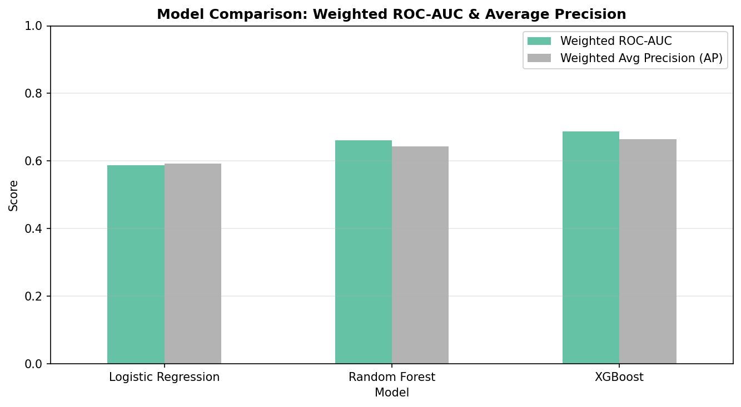The overall model comparison showed that ensemble learning methods substantially outperformed Logistic Regression.
Model | Weighted ROC-AUC | Weighted AP
Logistic Regression | 0.587 | 0.592
Random Forest | 0.662 | 0.644
XGBoost | 0.687 | 0.665
XGBoost achieved the strongest overall ranking performance, with the highest weighted ROC-AUC and Average Precision scores. Random Forest also performed strongly, while Logistic Regression remained only slightly above random classification performance. These results suggest that nonlinear ensemble methods better capture the operational complexity of airline delay patterns.

5.3 Precision-Recall Curve Analysis
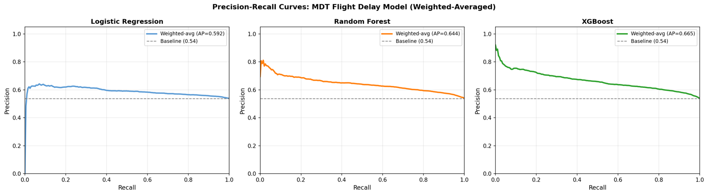
The precision-recall curves demonstrated important differences in model behavior under class imbalance. Logistic Regression produced weak precision-recall performance and remained close to the baseline throughout most recall levels. Random Forest maintained substantially stronger precision across increasing recall values, demonstrating more stable multiclass classification behavior. XGBoost achieved the best precision-recall tradeoff overall and maintained the highest precision across nearly all recall levels.
The weighted average precision scores confirmed this:
- Logistic Regression: 0.592
- Random Forest: 0.644
- XGBoost: 0.665
Because the dataset was highly imbalanced, the precision-recall analysis provided a more meaningful evaluation than accuracy alone.

5.4 ROC Curve Analysis
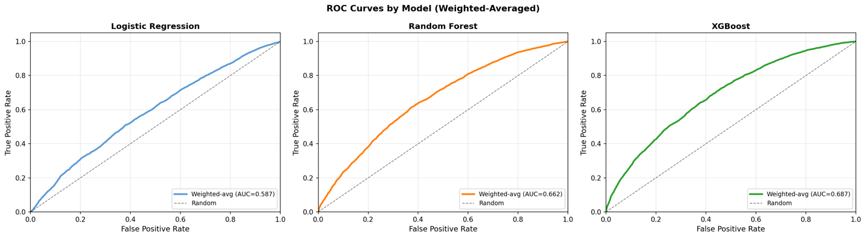
The ROC curves further illustrated the performance differences among the models. Logistic Regression achieved a weighted ROC-AUC of only 0.587, indicating weak class separation capability. Random Forest improved discrimination substantially with an ROC-AUC of 0.662. XGBoost achieved the strongest ranking ability with a weighted ROC-AUC of 0.687.
The ROC analysis demonstrates that ensemble methods were substantially better at distinguishing among multiple delay severity classes.

5.5 F1-Score Analysis
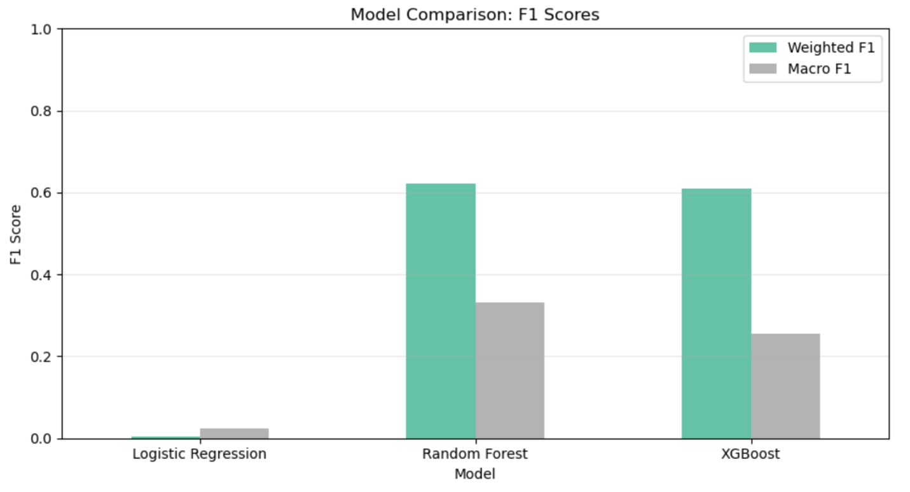
Model | Weighted F1 | Macro F1 | Accuracy
Logistic Regression | 0.0041 | 0.0245 | 0.0242
Random Forest | 0.6214 | 0.3319 | 0.6187
XGBoost | 0.6095 | 0.2556 | 0.6990
Logistic Regression failed almost completely, producing near-zero weighted F1-score and accuracy. Random Forest achieved the best weighted F1-score, indicating the strongest balance between precision and recall across classes. XGBoost achieved the highest overall accuracy but struggled more with minority classes, which lowered its macro F1-score. These results highlight how accuracy alone can be misleading under severe imbalance.

5.6 Logistic Regression Results
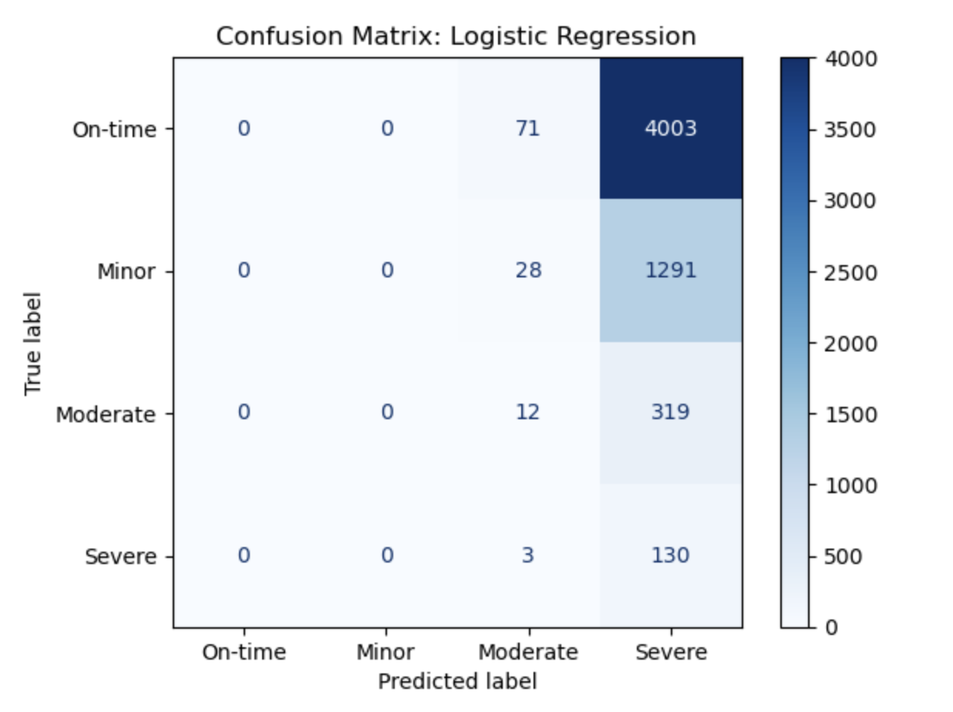
The Logistic Regression confusion matrix revealed severe classification collapse. The model incorrectly predicted nearly all observations as Severe delays. For example:
- 4003 On-time flights were classified as Severe
- 1291 Minor delays were classified as Severe
This explains the model’s extremely poor weighted F1-score and near-random performance. The linear decision boundaries used by Logistic Regression were unable to properly separate the multiclass operational patterns present in the data.

5.7 Random Forest Results 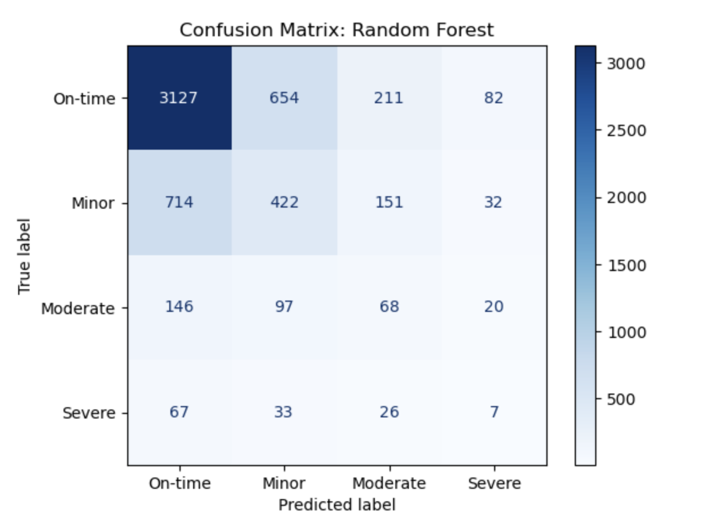
Random Forest produced the most balanced confusion matrix among the three models.
Correct predictions included:
- 3127 correctly classified On-time flights
- 422 correctly classified Minor delays
- 68 correctly classified Moderate delays
- 7 correctly classified Severe delays
Although Severe delays remained difficult to classify, Random Forest distributed predictions more realistically across categories and achieved the strongest weighted F1-score overall.

5.8 XGBoost Results
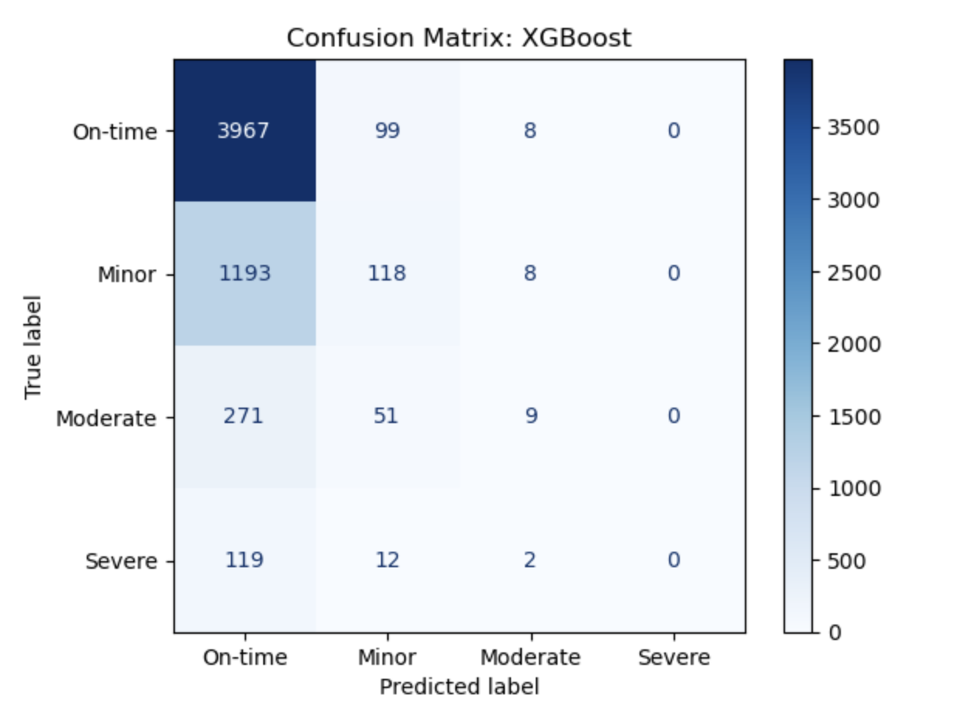
XGBoost achieved the highest overall accuracy and strongest ROC-AUC performance.
Correct classifications included:
- 3967 correctly classified On-time flights
- 118 correctly classified Minor delays
- 9 correctly classified Moderate delays
However, the model almost never correctly predicted Severe delays. This demonstrates that even highly advanced boosting methods struggle under extreme multiclass imbalance conditions.

5.9 Feature Importance Analysis
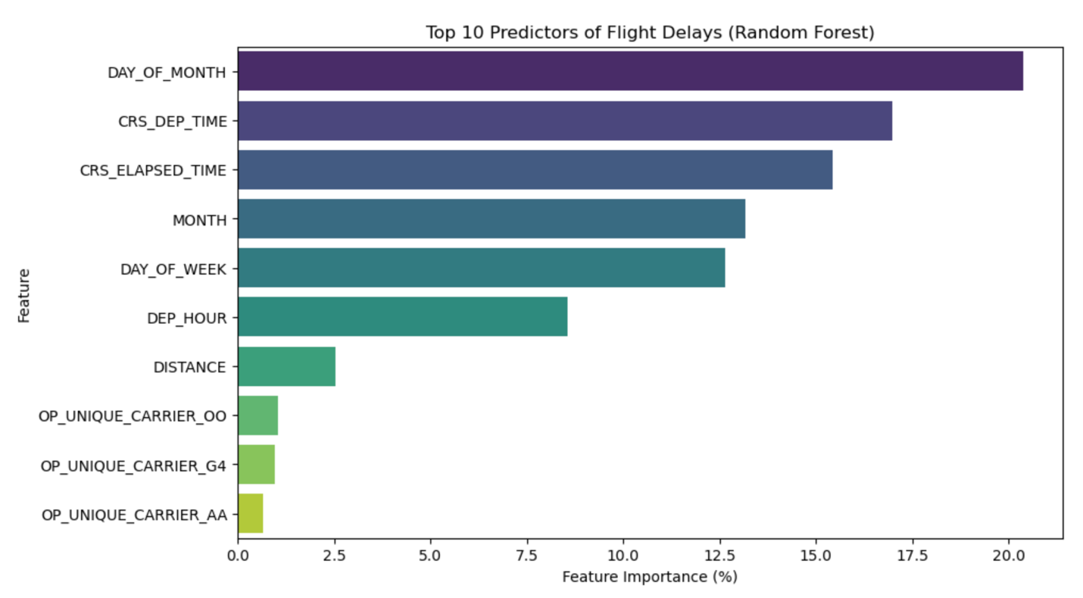
The Random Forest model identified several important scheduling and operational variables:
- DAY_OF_MONTH
- CRS_DEP_TIME
- CRS_ELAPSED_TIME
- MONTH
- DAY_OF_WEEK
- DEP_HOUR
These findings suggest that scheduling patterns and temporal congestion strongly influence delays.
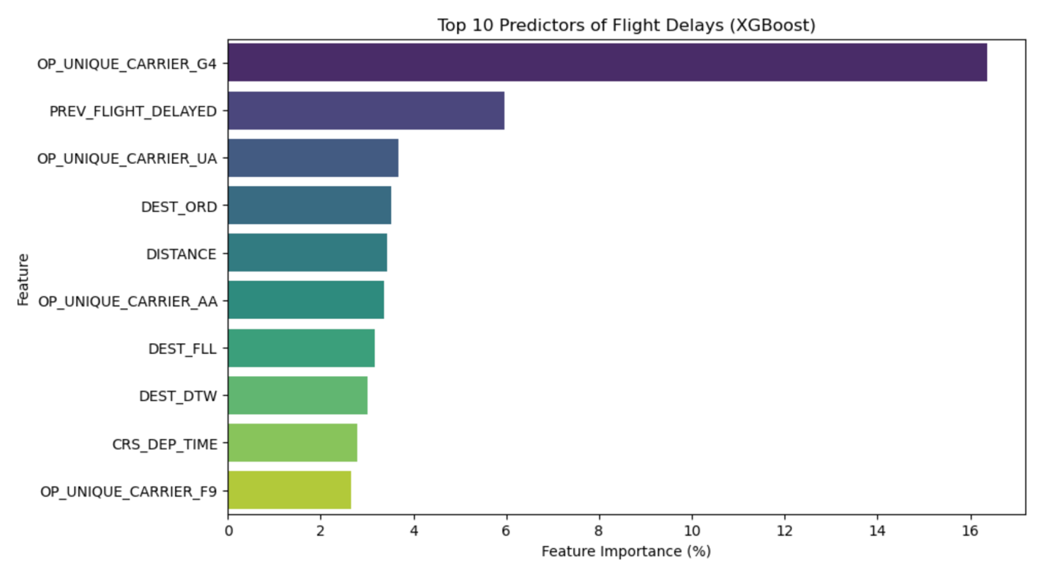
The XGBoost model emphasized:
- OP_UNIQUE_CARRIER_G4
- PREV_FLIGHT_DELAYED
- DEST_ORD
- DISTANCE
- CRS_DEP_TIME
The strong importance of PREV_FLIGHT_DELAYED supports the concept of delay propagation, where earlier disruptions influence later flights throughout the operational network.

5.10 Distribution of Predicted Probabilities
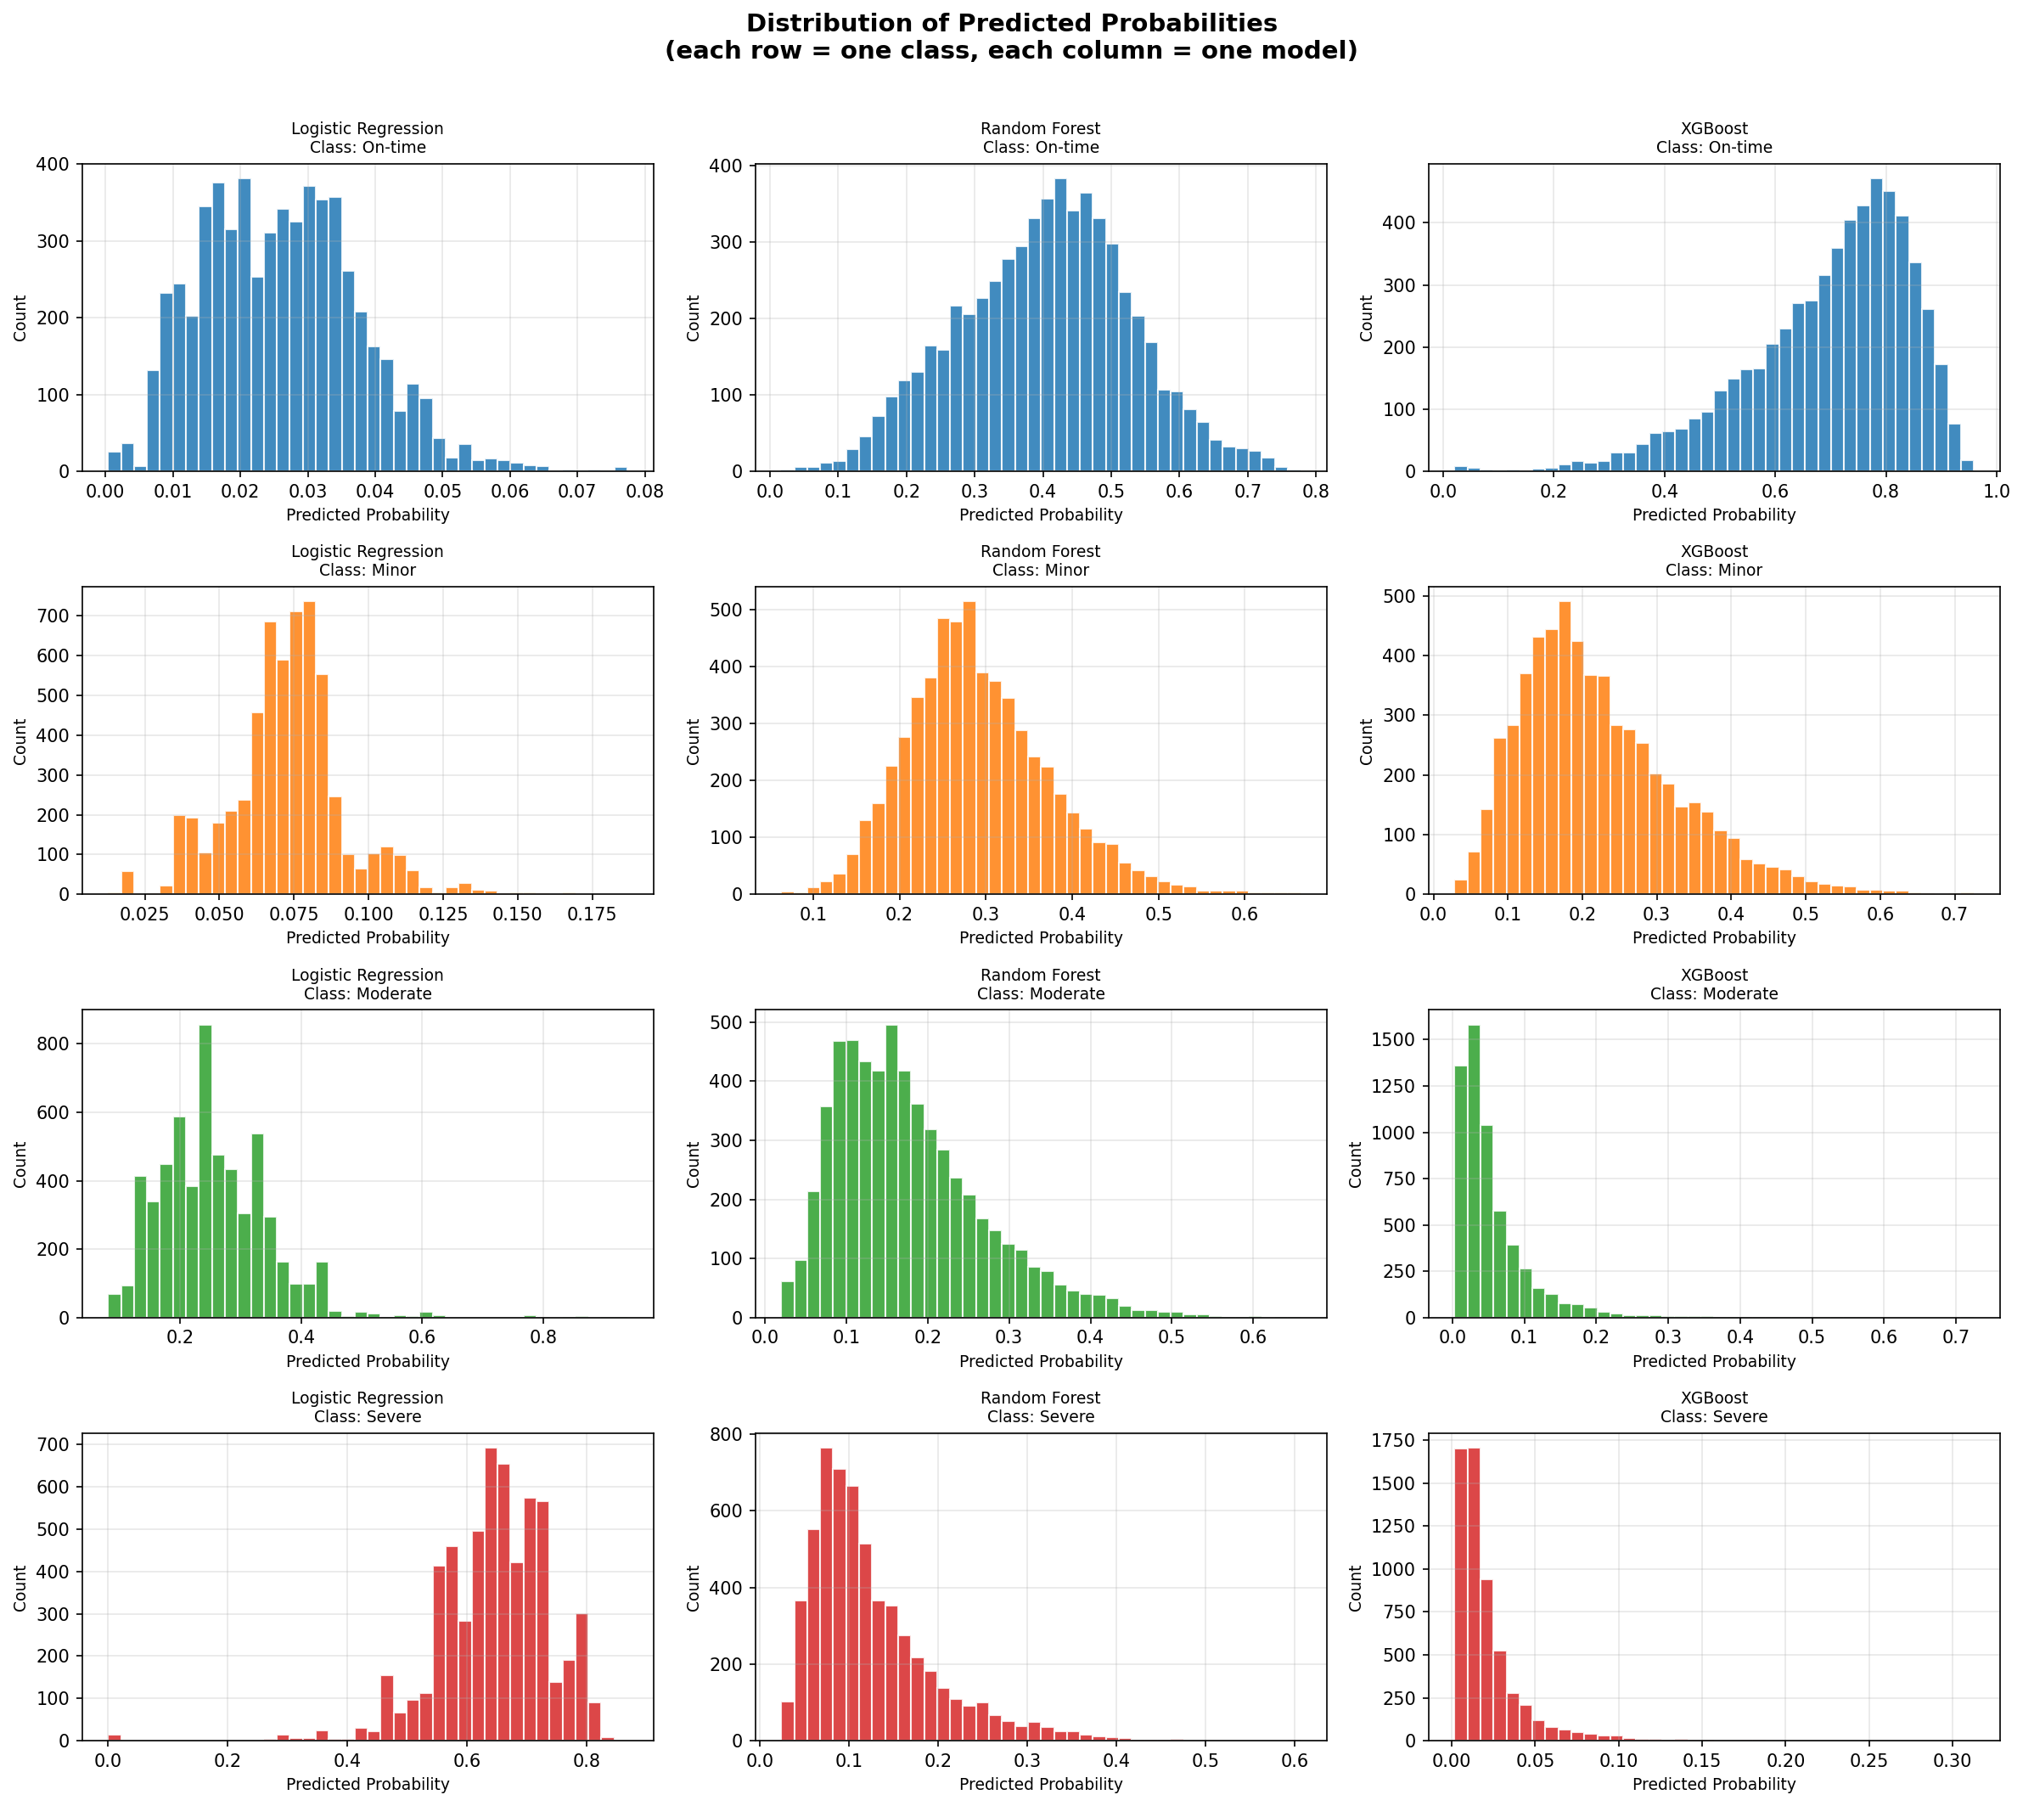
The probability distribution plots provide additional insight into model confidence and calibration behavior.
Logistic Regression produced highly unstable probability distributions and became heavily biased toward the Severe class. On-time flights received extremely low predicted probabilities, while Severe delay probabilities became disproportionately high, explaining the collapse observed in the confusion matrix.
Random Forest generated substantially smoother and more balanced probability distributions across all classes. Probabilities were spread more realistically across categories, which helped produce stronger weighted F1 performance and better minority class recognition.
XGBoost generated highly confident predictions for the majority On-time class, with probabilities concentrated between approximately 0.70 and 0.90. However, probabilities for Moderate and Severe delays remained concentrated near zero, indicating that the model became highly conservative when predicting minority classes.
These probability distributions reinforce the importance of examining calibration and probability behavior alongside traditional evaluation metrics.

6. Discussion of Results
The results demonstrate that ensemble learning methods substantially outperform linear models for multiclass flight delay severity prediction. Logistic Regression failed almost completely because the operational relationships within the dataset were highly nonlinear and heavily imbalanced. The model collapsed into predicting mostly Severe delays, producing extremely poor weighted F1-score and accuracy.
Random Forest achieved the strongest balance between precision and recall, as reflected by the highest weighted F1-score of 0.6214. The confusion matrix analysis showed that Random Forest distributed predictions more realistically across classes and maintained better minority class recognition than the other models.
XGBoost achieved the highest overall ROC-AUC, Average Precision, and accuracy scores. However, despite strong global ranking performance, the model struggled to correctly classify minority Severe delay observations. This occurred because the model became highly confident in predicting the majority On-time class while assigning very low probabilities to minority categories.
Feature importance analysis also revealed several operational insights. Temporal scheduling variables such as departure time, day of month, and elapsed flight time strongly influenced delay behavior. In addition, the importance of PREV_FLIGHT_DELAYED confirmed the presence of operational delay propagation across the airline network.
Overall, the results highlight the challenges of multiclass prediction under severe imbalance conditions and demonstrate why multiple evaluation metrics are necessary for realistic machine learning assessment.

7. Lessons Learned About Machine Learning Through the Project
This project demonstrated several important machine learning concepts:
- Real-world operational datasets are highly imbalanced
- Accuracy alone can be misleading
- Weighted metrics are critical for multiclass evaluation
- Ensemble learning substantially outperforms simple linear models
- Feature engineering strongly affects predictive performance
- Precision-recall analysis is essential for imbalanced classification
- Probability calibration behavior matters in operational prediction systems
- Minority class prediction remains difficult even with advanced models
The project also demonstrated that multiclass operational prediction problems are significantly more difficult than binary classification tasks.

8. Challenges Faced and Goals That Were Not Achieved
The most significant challenge was severe class imbalance. The Severe delay category contained only 133 observations, making it extremely difficult for models to learn reliable prediction patterns. As a result, all models struggled with minority class recall.
Another challenge involved Logistic Regression instability. Because the operational relationships in the dataset were highly nonlinear, the linear classifier failed to separate classes properly and collapsed into heavily biased predictions.
Computational complexity also became a challenge when training ensemble models and generating multiple evaluation metrics and visualizations.
Several goals were not fully achieved:
- Accurate Severe delay prediction remained difficult
- Minority class recall remained relatively low
- Weather variables were not integrated
- Airport congestion variables were unavailable
- Advanced resampling techniques such as SMOTE were not fully explored
- Real-time deployment was not implemented
- Hyperparameter optimization could be expanded further
Future improvements could include:
- SMOTE or other balancing methods
- Hyperparameter optimization
- Weather data integration
- Airport congestion variables
- Deep learning architectures
- Temporal sequence models
- Ensemble stacking
- Real-time deployment systems

9. Conclusion
This project compared Logistic Regression, Random Forest, and XGBoost for multiclass flight delay severity prediction using operational airline data from flights departing Harrisburg International Airport (MDT).
The results showed that ensemble learning methods substantially outperformed Logistic Regression. XGBoost achieved the strongest ROC-AUC and Average Precision performance, while Random Forest achieved the best weighted F1-score balance across classes.
The project also demonstrated that multiclass flight delay prediction is highly challenging under severe class imbalance conditions. Although advanced models performed reasonably well overall, minority Severe delay prediction remained difficult.
Feature importance analysis showed that scheduling variables, operational timing patterns, carrier-specific effects, and previous flight delays strongly influence airline delay behavior.
Overall, the project demonstrated both the potential and limitations of machine learning for real-world transportation analytics and operational prediction systems.

